Students

Tania Ribas

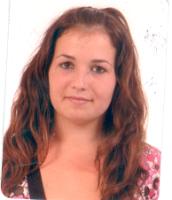
My name is Tania Ribas Alonso I am 15 years old, I was born in 1992.
I live in Olesa de Bonesvalls.
My mother name’s Sara, my father name’s Toni and my sister name’s Heidi.
My hair is brown and my eyes are brown.
My hobbies are listening to music and going out with my friends.

Tania Gil

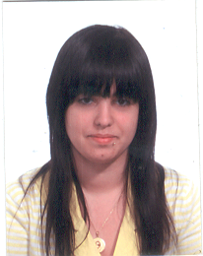
My name is Tania. I'm 16 years old. I live in Vilafranca it. I have a sister. My father named Felix and Rosa. I have a bird. My hobbies are listening to music, going out with my friends and go to the movies.
I am short and thin. My hair is black. My eyes are brown. I have a piercing and three pending.

Miriam
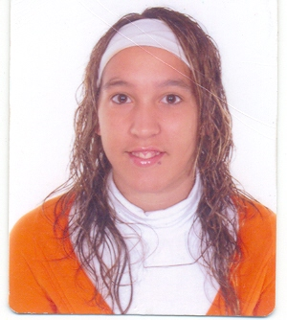
My name is Miriam Ojeda Lemos, I am seventeen years old, I live in Vilafranca del Penedès. I have one sister, her name is Vanessa. My parents name is Pedro and Loli. I have got one pets, a dog its name is Nora, it is very old. My hobbies are play a football, listen to music and going out witch my friends.
I have boy friends. My hair is brown, my eyes are brown.
I have got a two earring and two piercing.

Gerard
My name is Gerard, I am 16 years old.
I live in “Vilafranca del Penedès”, to Catalonia it’s not Spain. I have one sister. I don’t have to pets. My hobbies are playing in football a play in play station 2. I am tall. My hair is brown, my eyes are green.

Fran

My name is Fran Perea. I’m 16 years old. I live in Vilafranca Del Penedes. My sister name’s Elena and mi parent’s name are Montse and Jose. I have four pets, two dogs, a tortoise and birds. My hobbies are playing football, going to gym, listening to music and going out with my friends. I have a girlfriends that’s name is Montse. I’m tall and strong, my hair is brown and my eyes are blue and green. I have a earning, a pirsing and a tattle.



Pepe

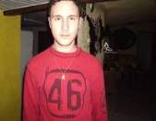
I am Josep Lluis Ros I am 16 years old, I life in Pacs del Penedès, I have got one brother and two sisters. My parents name are Jose and Maria Cinta, I have a dogs farm, and I have a lot of pets on my

house. My hobbies are play Basque ball, play computer and all times I listen RAP music.
I am tall and normal, my hair is black and my eyes are green.

David

My name is David Begara Vazquez.
I am 16 years old I live in Olesa de Bonesvalls.
I have one brother. My parents names are Hilario and Isabel.
I have got four pets a three dogs and one cat.
My hobbies are playing basketball, play table tennis ping pong going to the mountain with my dogs.
I am tall, slim, hair is brown.
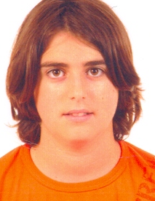

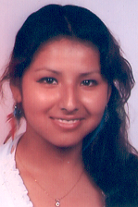

Fabiola

My name is Fabiola. I have 15 years.
I live in Vilafranca Del Penedès. I have 2 brothers. The name of my mother is Gabina and my father Juanito
My hobbies are playing music and singing. I am a normal height and body. My hair is brown. I have 1 earring.

Adrià

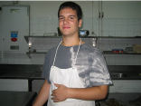
My name is Adrià Roman, I’m 15 years old. I live in Vilafranca del Penedès in Catalonia. I haven’t any sister and any brother my parent’s names are Joan and Remei, my hobbies are the human’s towers with “Castellers de Vilafranca”, the music, msn, the photolog, the blog, …, I have black hair the eyes green-brown. I am 1,75cm tall. I haven’t any pet but before I had one.

Javi

Hi, my name is Javier Castaño. I am 16 years old. I live in Sant Cugat Sesgarrigues. I haven’t any brothers on sisters. My parents names are Juan and Mari. I have got two pets, a dog and rabbit. My hobbies are riding motorbikes and playing basketball. I am tall and strong, my eyes are colour brown and my hair is brown. I have got two earrings.

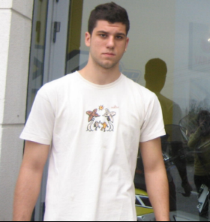

Eva
My name’s Eva. I’m 16 years old. I live in Vilafranca del Penedès. I haven’t any brothers on sisters. My mother names is Dolors. I have got one pet, a dog call Nit. My hobbies are listening music and go out with my friends. I am tall and thin. My eyes are colour brown and my hair is blond. I have got 4 earrings.
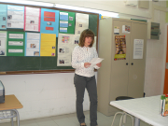

Jallal



My name is Jallal Benaija I 17 years old, I was born in Morocco, and I live in Vilafranca 14 year old I live in Spain, my parents names are Ahmed and Fatima, I have 4 brothers Ian one sister
I me favourite music is Rap and the sport is football.

