CATALAN GROUP IN BERLIN

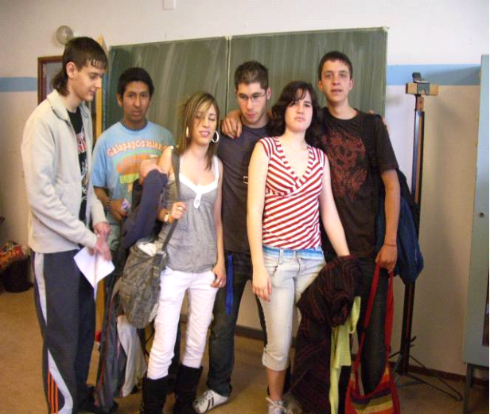

Ana

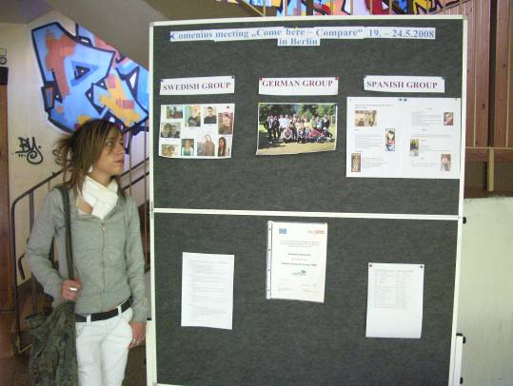
This trip has been an experience that I’ll never forget, Berlin is a beautiful city and it history is very interesting; I liked knowing people from other countries with other culture and very different habits comeback from ours. We sew the differences from a country to another, etc.
I expect some day to come back to to Berlin, thank you for this opportunity.

Francesc

The best I liked was to know new people from other countries.
I didn’t like to go enterprise from 9:00 to 4:00 in the afternoon.
When we stayed in the enterprise we saw that they have a different way of working and I liked comparing the two systems. The fact of traveling to another country made me think that there many people ride bicycles and here we spend a lot of money on cars.

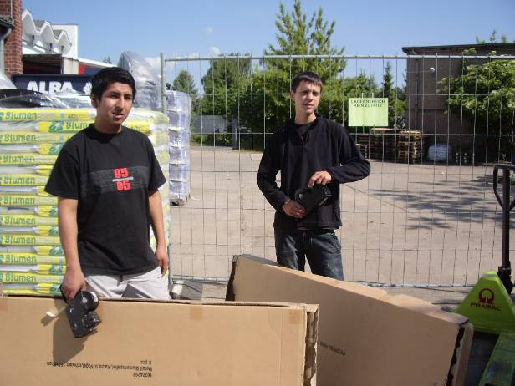
Jose
On the 19th of May we went to Berlin by airplane and the German teachers waited for us at the subway station, Afterwards we went to the hotel that was near the subway, and some minutes later the Swedish arrived at the hotel.
I liked the German culture their food, the hours of getting, to work going to their enterprises, and also the climate, I didn’t like speaking in English in public.

Marta

I went to Berlin to make an experience with, Sweden, Germany and Vilafranca del Penedès to know their culture and about everything for example, how they do the Module of productive learning, if it is the same as here, etc. Besides we went in an enterprise two days, and they, work there three days.
I enjoyed the days there I enjoyed it very much, and it was unforgettable experience.

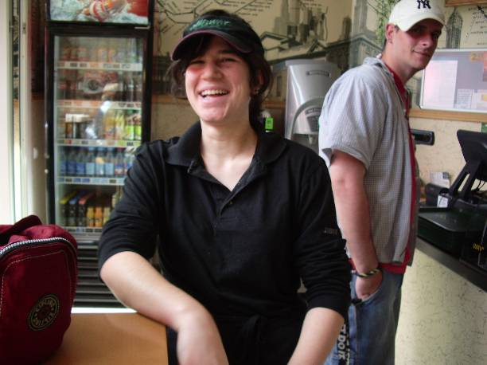

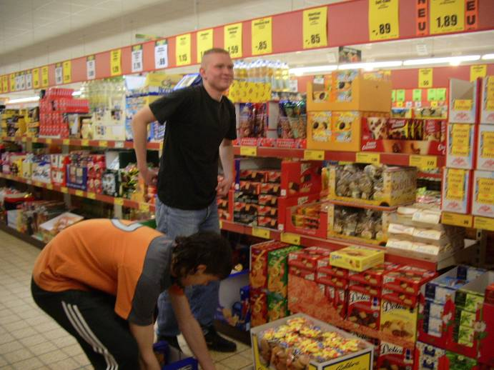
Sergi
On the 19th of May we went to the airport of Barcelona the plane went at 11 and we arrived at two and we went to a sports center to make a barbecue.
We went to their enterprises with the German the enterprise was a supermarket, I was very well and learned to tidy up the food and the bottles, and throw away boxes. In the afternoon we remained in the hotel with the Germans and the Swedes.
The 3rd day I went also to the enterprise. In the afternoon we went to finished the work of our country.

﻿The 4th day in the morning we went to the German school to have dinner and to present the work of our country. The Swedes also presented it. In the afternoon we went to visit the city.
The 5th day we went to see the bunkers, I liked them a lot, and in the afternoon we went to with a restaurant where the Germans organised a party.
The 6th day in the morning we went towards the airport of Berlin and we arrived at Barcelona airport at 4’30.

I liked it staying with the Swedes and Germans, also I liked to see the things that Berlin has. And also on Thursday I presented the
I did not like the food that they gave us very much.
The fact of travels another country has made me see a different culture, the things are very different and I liked it all very much.

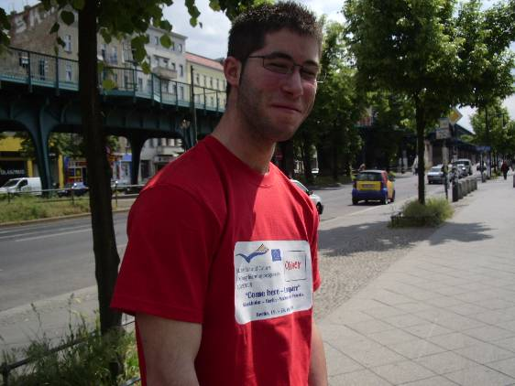

Oliver

It went all very well. Swedish and German people are good and they were very friendly with us.
When I went to the enterprise that I had to go (it was a sports Centre), I realised that their kind of Productive Learning wasn’t too different from ours. The differences between their Productive Learning and ours were that they have a school only for them and that they are staying two years in the School

